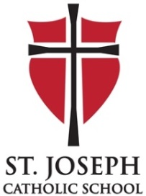
FAMILY SHARE HOURS

WHAT ARE SHARE HOURS?
​St. Joseph Catholic School, as a ministry of the larger community of St. Joseph Parish, embraces stewardship in the form of contributing our time, talent, and treasure. Its success is dependent upon the volunteer efforts of the parent and parish community.
To support the school with this commitment, each family contributes 30 share hours (20 hours for single parent families) of their time and talent to the school and parish (For those families receiving a subsidy from St. Joseph Parish, 10 of the 30 (20) share hours must be in a Church ministry). New Families: In your first year only, the hours are reduced to 20 (15 for a single parent) in order to allow time to get to know the school community.
Items purchased for donation to the school (ex. the purchase of food for staff in-service days or donations for a class party) may be counted toward share hours as $25 = one share hour.
Each family is asked to account for their hours and submit them on the Share Hour Online Reporting Form. The share hour year runs April 16, 2019 to April 15, 2020. If a family’s share hour obligation is not met by April 15, a fee of $25 per hour remaining will be charged.
Parents, grandparents, and siblings (high school or older) are eligible to work to earn share hours.

